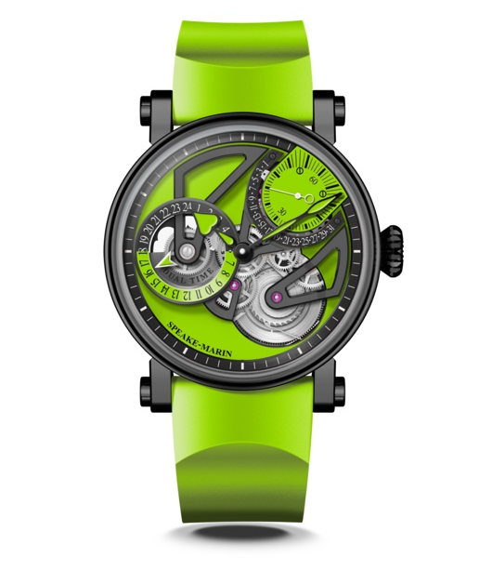
Dual Time LIME

MOVEMENT SMA02 Calibre, self-winding movement with micro-rotor
Retrograde date and Dual Time indications

INDICATIONS Hours Minutes and Seconds
Small seconds and retrograde date at 1h30
Dual Time indication at 9 o’clock

DIAL Openworked dial. Black mat finish.
24 hours Dual Time indication in black and lime green.
Heart-shaped lime green lacquered hands.

POWER RESERVE 48 hours

CASE Piccadilly case in black DLC-coated titanium.
Front and back sapphire crystal treated with anti-reflective coating.

DIAMETER 38 or 42 mm

WATER RESISTANCE 3 bar (30 metres)

STRAP & BUCKLE Lime green rubber, pin buckle in black DLC-coated steel

LIMITED EDITION 38mm : 10 pieces | 42mm : 18 pieces

REFERENCES 38mm : 413816390 | 42mm : 414216390

PRICE 38mm: CHF. 30 870 without tax| 42mm: CHF. 31 395 without tax

